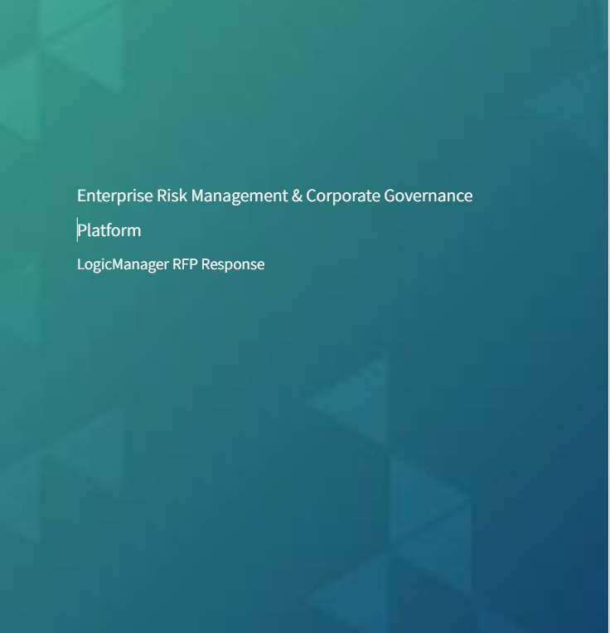

As a company with extensive experience in reviewing hundreds of RFPs, we have developed a customized template based on the most frequently asked questions we encounter. This template is designed to streamline the RFP process, saving valuable time for all stakeholders. Our RFP not only efficiently addresses common queries but also showcases our core strengths, aligning seamlessly with market demands. We are happy to complete your RFP or answer additional questions if you feel our template does not meet your needs.
Company Overview:
Parent Company: LogicManager
Address: 6 Liberty Square #2316, Boston, MA 02109
Website: LogicManager.com
Service: Corporate Governance/Enterprise Risk Management
Type: SaaS
LogicManager Background:
At a high level, LogicManager is a Corporate Governance platform. Our approach allows organizations to integrate multiple risk management processes across departments and functions. This enables effective and responsible decision-making from company leadership, while also ensuring effective communication of risk goals and program performance up and down the organization. The goal of corporate governance is to enable organizations and their leadership to uphold their fiduciary duties to protect the interests of all stakeholders and create long-term growth and sustainability. Through proper oversight of risk management processes and responsible decision-making, our clients can effectively prevent fraud, waste, negligence, and abuse.
Company Profile:
LogicManager was founded in 2005 as an enterprise risk management organization. In 2008, the RIMS Risk Management Society, a longstanding partner of LogicManager, published the results of our work; proving a direct correlation between better business performance and a higher degree of adherence to the Risk Maturity Model.

Today, LogicManager provides powerful risk management software with comprehensive solutions that supply organizations with focused and improved risk management processes. Our software allows you to centralize your risk management program into an all-in-one hub while streamlining your processes with a range of automated tools that allow for better risk identification, monitoring, and reporting. We were inherently built as a centralized software, therefore information flows seamlessly between each area, instead of acquiring pieces that may not speak to each other as well. Additionally, we pair customers with our team of expert thought leaders and risk management consultants to get your business to go exactly where you want it to go.

With a range of personalized training sessions and best practice consulting services, our team can make your hard work easier and deliver results to both protect and optimize your business all while not charging professional service fees. Our strategic vision is delivering no-code enterprise solutions, integrating machine learning, and becoming a centralized hub for all technologies in a company’s ecosystem.

Our approach/Differentiators:
All-in-One Centralized Software: Our software was purpose-built to be interconnected – across our governance areas and our clients’ core systems – serving as a single source of truth for your organization. We want to break down silos to improve information sharing and efficiency, not create artificial barriers between departments within the software. Our solutions are designed to work perfectly together or seamlessly apart.
Expert Advisory Support: We pair customers with our team of expert risk management consultants to get your business moving forward. With a range of personalized training sessions and best practice consulting services, our team makes hard work easier and delivers results to both protect and optimize your business.
Solution Library: Our solution packages are customized, out-of-the-box bundles that include various software features, content, tasks, workflows and other automations to help you achieve specific initiatives and programs quickly – all while following a risk-based approach.
Integrations: From your trusted ERP platform, to your HR system and everything in between, the core systems driving your work today can be seamlessly integrated with LogicManager, delivering more efficiency and effectiveness across all of your departments and applications with our open API.
Zero- Code Configuration: LogicManager was built to support self-sufficiency, meaning you need little to no IT involvement to get up and running.
Risk Maturity Model: A partnership with LogicManager grants you access to the Risk Maturity Model. The RMM is a best-practice framework that facilitates corporate governance by promoting a two-way conversation with your board, risk committees, and risk officers. Board-level reporting allows for an easy assessment of your ERM program maturity and puts a spotlight on any gaps in risk coverage. Highlighting the gaps in your risk program is key when asking the board for additional investment or hiring resources for mitigation. By providing benchmarking KPIs against industry standards, actionable steps to improve your risk program, and reporting ready to deliver to your board.
No Surprise Pricing: Unlimited licenses for the areas of the application you plan on using. Our pricing model also includes access to content, workflows, and reports at no additional cost.
LogicManager Key Solution Areas:
Enterprise Risk/Risk Assessments: LogicManagers enterprise risk management software enables you to uncover risk across the enterprise, evaluate your most critical risks, and develop effective mitigation and monitoring activities. This includes pre-built libraries and assessments, automated task notification, control testing, issue management, and robust reporting.
IT Governance & Security: LogicManagers information technology and security solution packages allow you to identify critical risks, adhere to compliance requirements, and objectively prioritize which concerns require increased attention and allocation of resources.
Third-Party Management: LogicManager’s vendor management software provides the foundation needed to maintain the full lifecycle of all your relationships. This includes onboarding/offboarding, ensuring compliance with your key requirements, tracking vendor issues, recording due diligence responses, uncovering vendor dependencies, and prioritizing top vendors through assessments and key risk indicators.
Event Management: LogicManagers event management area allows you to create a standard framework for collecting, analyzing, and acting on any of event: such as a breach of privacy, financial loss, fraud, audit issues, compliance, and more. We can provide pre-built event templates and offer you the ability to create your own. When events are triggered the system can use workflows to engage with the appropriate parties, identify key due dates, and assign actionable steps to resolve what events that have been submitted.
Policy Management: LogicManager’s policy area provides a central location for the entire policy process, including drafting, approvals, review, updates, and even attestations. This enables you to gain efficiency in how your organization communicates and shares information.
SOX: LogicManagers SOX package helps to streamline financial reporting requirements using standardized risk assessments, control management, and testing. Our software provides transparency into operational risk, key controls, and testing activities to the main accuracy in financial reporting requirements and ensure proper documentation for compliance.
Business Continuity: LogicManagers risk-based business continuity solution helps with disaster recovery planning, business impact analysis assessments, and assurance that critical business areas will not be disrupted in the event of a challenge or disaster.
Audit Management: Using LogicManager’s Audit solution, you can manage your audits from reviewing your audit universe and doing the initial planning and scoping, to performing the fieldwork, to tracking any issues and findings that were identified through to completion. Risk based approach - we take a risk-based approach to audit to help organizations prioritize their time and resources auditing the areas that need it most, both in prioritizing what audits need to be conducted, and also in prioritizing what controls need to be tested and reviewed.
Compliance Management: LogicManagers integrated compliance software provides a standard framework to assist customers in streamlining their compliance management concerts and staying up-to-date with automated alerts and notifications.
Customizable Reporting: LogicManager has a flexible, built-in reporting engine that enables you to access information in a variety of formats to meet the needs of your organization. Different stakeholders may want different views of the same information depending on the level of granularity desired. The reporting engine allows you to create completely customizable reports and dashboards to fit those needs, whether it be an export to Excel for easy data manipulation or a high-level dashboard to quickly identify trends
Workflow & Task automation:
LogicManager’s workflow tool allows you to construct a workflow with multiple decisions (or "branches"), notifications, and approvals to logically automate the process and keep the right people informed. Any number of workflows can be created and stored in the system whether it be approving a new vendor or reviewing an updated contract. This will help to create efficiencies in your program by automatically triggering the appropriate actions based on your needs.
Tasks can all be email integrated, this allows for quick adoption of the platform!
Implementation & Support/Training: LogicManager’s implementation period and ongoing support model are designed with your best interests in mind. We aim to be your mission-critical partner and will target our resources to meet your goals. Understanding that your success is our biggest priority, implementations are done at the solution area level. To get you off the ground you will be paired with a dedicated Implementation Specialist to get you started off on the right foot, as well as a Customer Success Representative who will be there throughout the entirety of our partnership. Equipped with best practice expertise and all of the knowledge about our tool that’s needed to excel your program, our risk experts provide their unlimited support at no extra cost.
Our implementation is focused on a strategic content setup and not a technical configuration.
• There are no additional charges or professional service fees for configuration - we are here to help!
• LogicManager’s flexible and easy-to-use software is designed for end-user engagement.
During implementation, we start with a kick-off call, where our team will work with you to better understand your key challenges and business mile (short and long term). Each implementation is tailored to the organization, but we do provide a step-by-step implementation plan as a starting point.
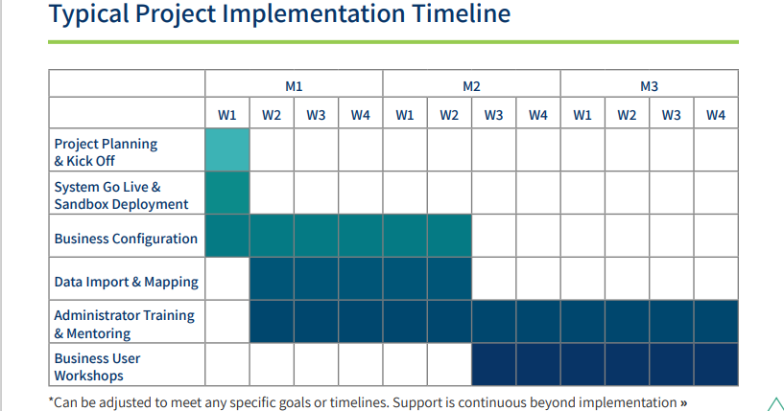
The implementation also includes training resources. This includes access to a full knowledge center that includes workshops, product walkthroughs, blogs, case studies, and best practice guidance.
The overall training methodology is to train the trainer. We will train you and your colleagues in manageable steps using your own data, providing session recordings and other documented guidance along the way. Our goal is to ensure your understanding and confidence in the system through constant communication with your advisory analyst. You will have recurring meetings to make sure we are working at your pace.
- Implementation and training also include the following:
  - Assistance with setting up users and roles in permission.
  - Data migration
  - Process testing in sandbox environments.
  - Best practice recommendations
  - Access to downloadable content to get you off the ground.
Data Migration: Customers can import data they would like to store in LogicManager using the Data Load Utility. Data can be exported to PDF, Excel, PowerPoint, Word, Postcript and XHTML. During initial setup data migration is included in our implementation cost and done by your dedicated implementation team.
Reference: Out of respect for our client's time, references cannot be set up during the RFP/RFI process. If LogicManager is a selected vendor or is shortlisted we would be happy to connect you with a similar client (Solution area, industry, or size)
Learn what are customers have to say here
Security Information
- Agile approach to software development
- All connections to LogicManagers platform are established through TLS 1.2 protocol and support 256 bit encryption strength
- Customer data is segmented into their own schemas
- LogicManagers database is encrypted
- Annual external pen testing
- Scanning of production code
- Vulnerability scanning on external facing and selected internal facing IPS
- Well-thought-out incident response policy
- DR/BCP
- Change Management policy
- Annual Security Awareness training
- Data Centers: LogicManager is a SaaS-based solution that is hosted in Oracle Cloud in either the USA, EU, Middle East, or APAC.
- SOC 2 Certification

Here are some additional questions asked!
Commonly asked questions | Our responses
How long have you been in business | LogicManager has been operating since 2005
How many employees do you have? | appr. 100
What verticals do you work with? | LogicManager works with organizations of all sizes and verticals.
Do you provide any content to get us off the ground? | Yes, we have developed a content hub so you don’t need to reinvent the wheel. This content includes: risk libraries, workflows, due diligence questionnaire, events forms, and more.
Do you have a SOC2 Report? | Yes, this can be provided after an NDA is executed
How long are implementations? | Between 8-12 weeks per solution area
Please explain permissions and uses access in LogicManager | LogicManager supports a fully configurable, granular set of role based access controls. Permissions can be assigned to a specific user or user groups can be created for ease of maintenance
What is your SLA time for incidents? | Please see- https://www.logicmanager.com/service-level-agreement/
Do you have technical support? | Yes, technical support is provided 24x7x365
What systems can you integrate with? | LogicManager has the ability to integrate with other information systems through a range of application technologies, including APIs, web services, as well as traditional export/import functionality. Most modern applications do not pose a significant technical hurdle to integration. There is no extra cost for creating integrations.
Do you attend any conferences? | No, but every year, we host an annual customer conference called IMPACT where we engage our customer base, discuss best practices, and allow the customer community to network and share ideas.
Do you offer a Sandbox environment for testing? | Yes, a sandbox environment can be provided after purchase for controlled testing
Do you offer an on prem system? | LogicManager is a SaaS based solution. We do not offer an on prem system
Do you take customer feedback | LogicManager has built our product from customer feedback over the past 18 years. Our service model puts the customer first and in an effort to continuously ensure our customers are on the forefront of industry best practices, we update our product on a monthly basis. Our product enhancements and changes are based 100% on our existing client recommendations, and we’re continually conducting market research to anticipate current and future needs.
How often do you update the application? | Every 6-8 weeks
Do you have any audit trail capabilities? | LogicManager maintains a full audit trail of changes in the platform. Updating vendor information, changing risk scores, updating control owners, etc. All historical / audit information can be incorporated into a report.
Do you have a data storage limit? | No, we do not have a data storage limit
Have there been any mergers, acquisitions, divestitures or joint ventures? | No, LogicManager has not been through any mergers or acquisitions.
Describe your solution's strategic direction | LogicManager's strategic direction is focused on delivering no-code enterprise solutions, integrating machine learning, and becoming a centralized hub for all technologies in a company's ecosystem. The company aims to provide powerful risk management software with comprehensive solutions that supply organizations with improved risk management processes. The software centralizes the risk management program into an all-in-one hub and streamlines processes with a range of automated tools for better risk identification, monitoring, and reporting. The company also provides unlimited access to dedicated business analysts for the lifetime of a subscription to complement technical support. LogicManager's strategic vision also includes tailoring implementations to individual organizations' priorities and milestones.
Have you ever been through a data breach? | We have not experienced a data breach since 2005. Many of our direct competitors have experienced breaches in the past 2-3 years.
Can you provide financials? | As a privately owned organization, it is company policy not to share financial documents. However, we are an organically grown and cash flow positive organization that is in great financial health. We are happy to provide a Rapid Ratings report with an independent third party evaluation of our financial strength.
What is your pricing model? | Our pricing model is typically based on a solution area module basis. Our goal is to provide you access to the areas of the system that will allow you to accomplish your strategic objectives.
How do you handle system updates? | Notification of Release Maintenance will be sent to customers as soon as the time frame for the update is known. An email will be sent to a customer list of personnel maintained for each customer.
Do you support email task notifications to end users? | Alerts, reminders, tasks, and notifications throughout the system keep users informed of responsibilities.

